TO : ALL WATER DISTRICTS IN TH EASTERN VISAYAS

SUBJECT : DBM PROCUREMENT TRAINING/WORKSHOP

DATE : SEPTEMBER 10-12, 2014

X ==============================================/

The Department of Budget and Management, Region 8, will be conducting a Training/Workshop on Government Procurement Reform Act (GPRA) Updates on September 10, 11, 12, 2014 which will be held in Sabin Hotel and Resort, Ormoc City.

In view of this, Regional Director Imelda C. Laceras of DBM is personally appealing for the EVAWD to participate in this very significant aspect in discharging the duties and responsibilities of the government on matters of procurement.

It is in this instance that we are calling all members of EVAWD to compulsorily attend this three (3) day workshop by indispensably sending the BOD members who is the Head of the Procuring Entity, General Managers, Procurement Section and members of the Bids and Awards Committee in the proper conduct of procurement activities of our respective offices.

Attach herewith is the invitation from the Department of Budget and Management for more information.

Thank you for your continued support to our association.

This 1st day of September 2014 at Baybay City Water District.

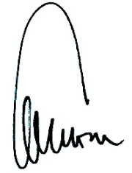
Thank you.

CYRIL LUIS L. ARRADAZA

